**Conferting If Statements to CFG**

[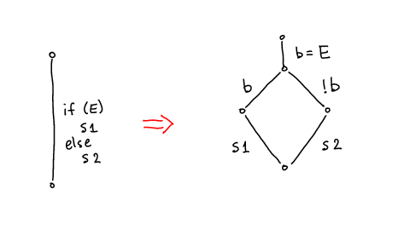](http://lara.epfl.ch/web2010/_detail/cc09:tr-if-cfg.png?id=cc09%3Aif_statements_to_cfg&cache=cache)

Note: better translation uses two destination vertices, analogously to [Compilation as Tree Transformation](http://lara.epfl.ch/web2010/cc09:compilation_as_tree_transformation)